BOOK LAUNCH AFTERMATH

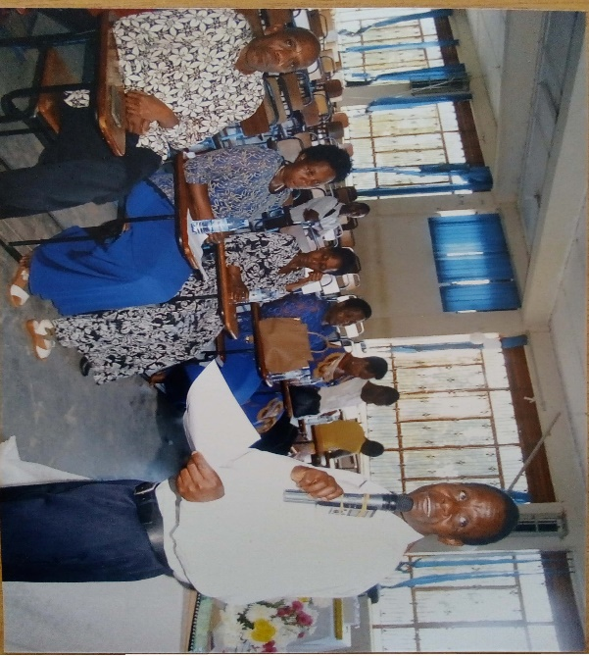
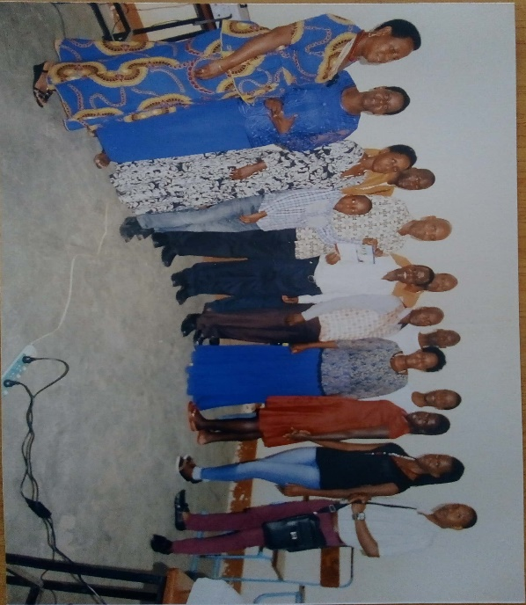
Images
Introduction.
The book was launched on the 19th October 2019.
A long journey to reach this stage of academic publishing!
In his introduction the chair recognized the presence of all the invited guests and thanked them for coming. Being the first of its make, he thanked family members of Mr. John Baptist for encouraging and supporting him to have the publishing project of the text kickstarted at Mbarara University of science and Technology as another a way to enhance research and development agenda.
Book presentations
Author; Mr. John Baptist Kamushaga presented a brief message about his book ‘’Enhancing Manpower Abilities’’ using a slide book trailer.

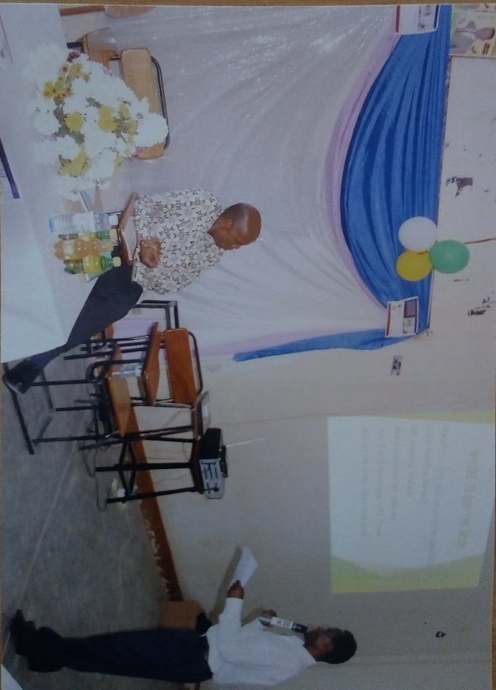

The purpose of wring was to inspire university students, graduates and human resource development officers generally to innovate practice. This is an identified gap university need to invest in so as to enhance the culture of reading and writing that is declining in Africa and other developing economies.

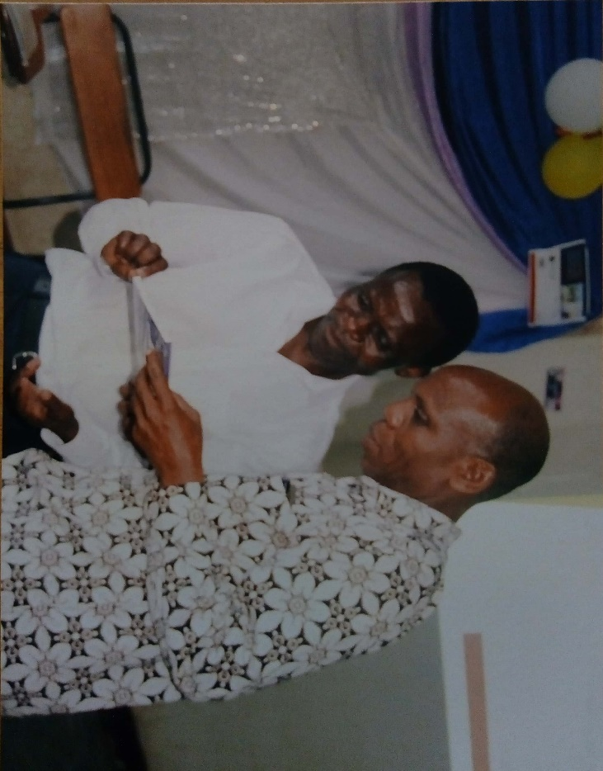
He challenged local elites always to encourage learners to have their work published as the other creative and innovative way to fit in the home and global markets. One of the weaknesses institutions of higher learning have, he said was lack of effective communication for the learners to be understood and this can be overcome by those in positions of responsibility to give the right message about today’s world of work in a clear, well enunciated manner and language.
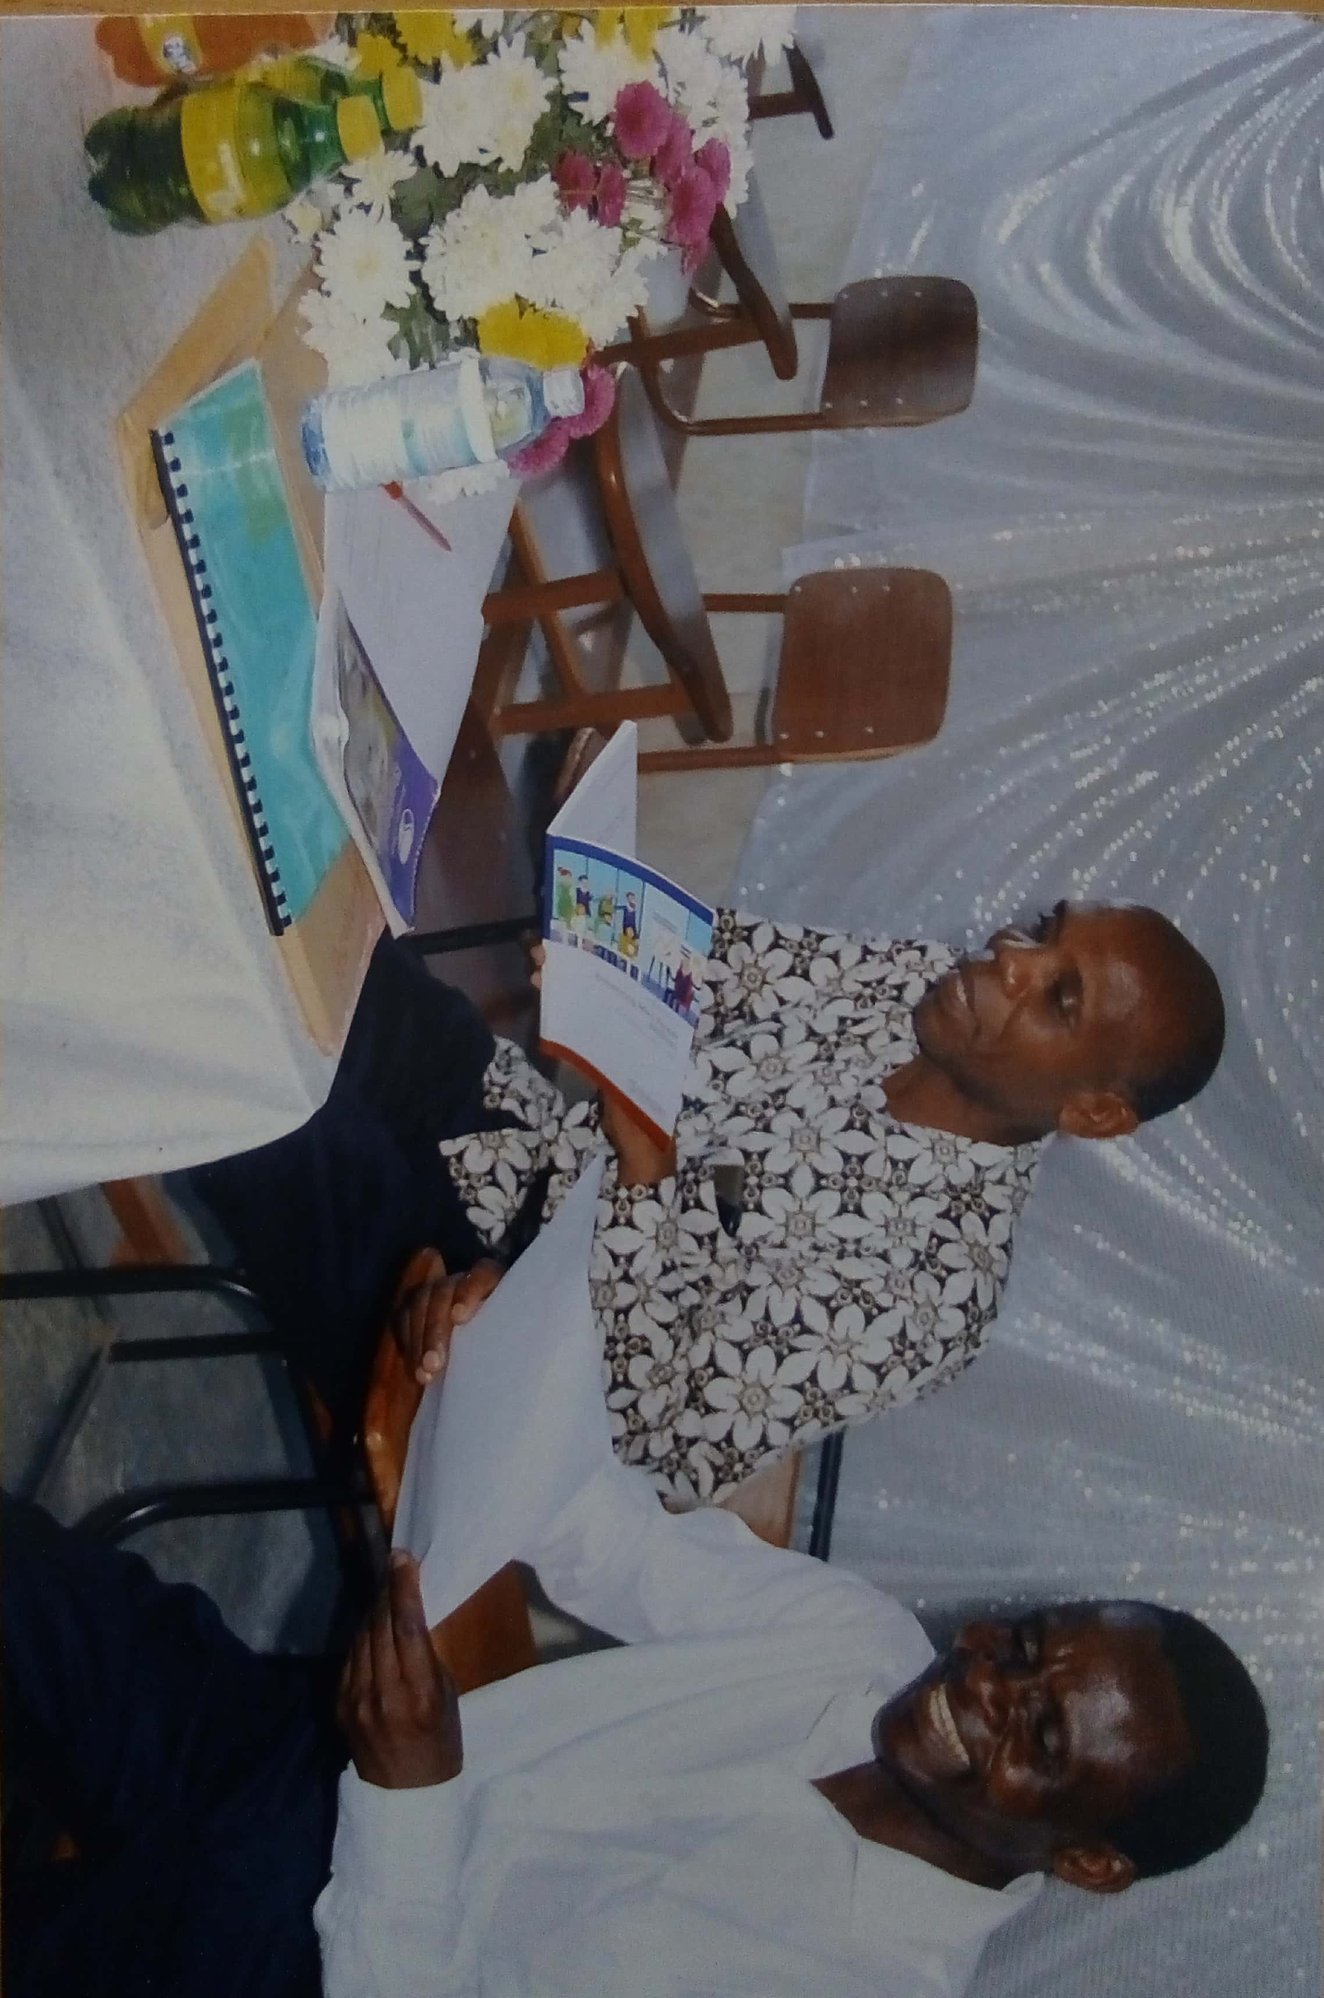

Prof. Jerome Kabakyenga
The guest honor. A humble man of great repute and respect at MUST and beyond.
His word of wisdom was that universities must conserve African culture and values and that publishing is the educated way to go. He thanked the author and management for choosing him to preside over the book launch function and asked the good lord to make it possible the project takes root.

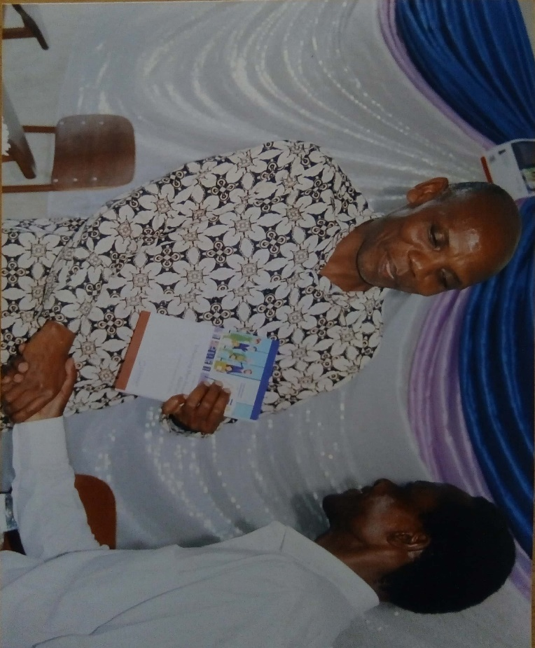

Thanked all members behind the project especially peer academicians, supervisors, parents and management for their support and urged them to ensure this project is realized.
Book signing ceremony (On your journey of publishing)
The book was signed and immediately released for public consumption at a cost of 35000/= (Thirty-five thousand ug. Shs. Only). The guest of honor Prof. Jerome Kabakyenga animated the event in the most hubbliest way.

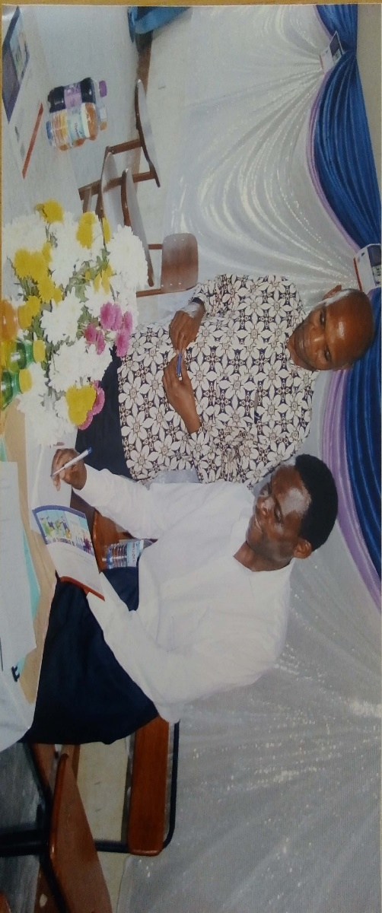

The cake and sharing.
It was fun and fulfilling. The culture of food in Africa.

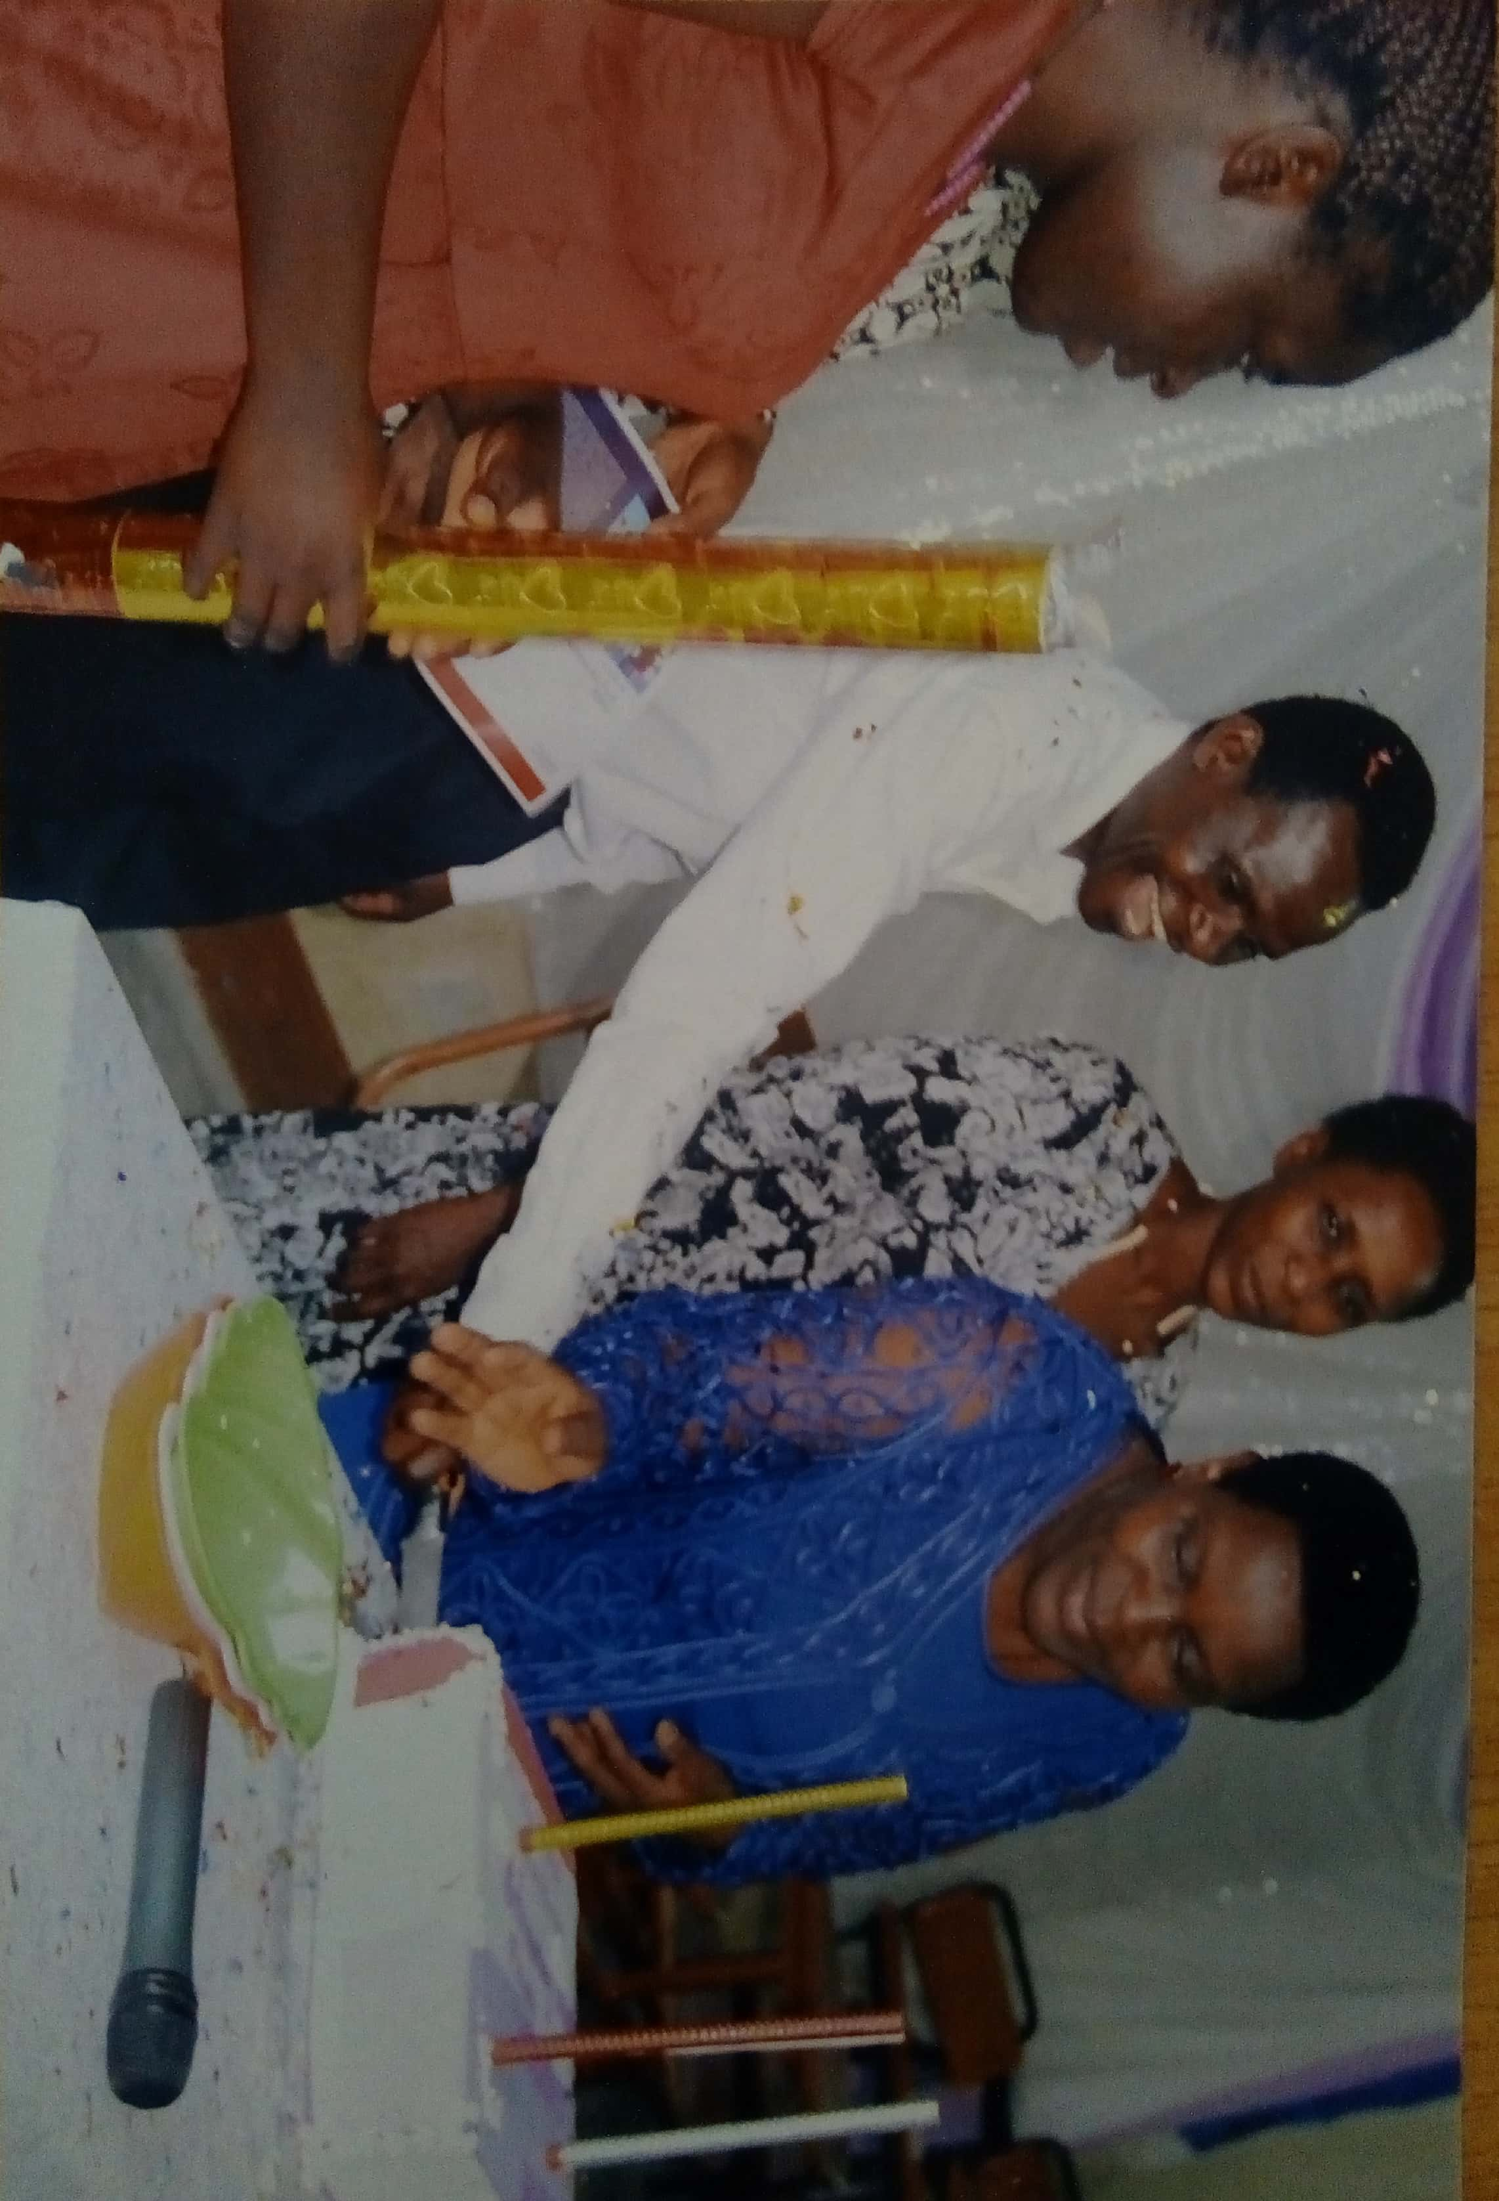

The book covers of the launched book were improvised as serving plates because there were few serving plates. The very book covers were given to guests as a gift to go home with. Students of MUST who were serving the guests devised this method to make sure the cake reaches everyone and as a marketing strategy for the project. The sharing was accompanied by cool music.
Closure
The book launch ceremony was closed at 6.00pm wishing everyone good luck and safe journey home.
John Baptist Kamushaga Aurhor.

